**Fruit Ninja Game**

**Team Members:**

**Alaa Iraqy 5428**

**Omar Emara 5385**

**Omar Khaled 5562**

**Hossam El Kady 5446**

**Shimaa Ahmed 5556**

**Fruit Ninja Game**

**Description:**

Fruit Ninja is a simple game of slicing fruit. Holding the device sideways, players use their fingers to slice the pieces of fruit that jump into the screen. As the game progresses, more and more fruit come onto the screen, and players can slice multiple fruit at once to score combos.

**Main menu:**

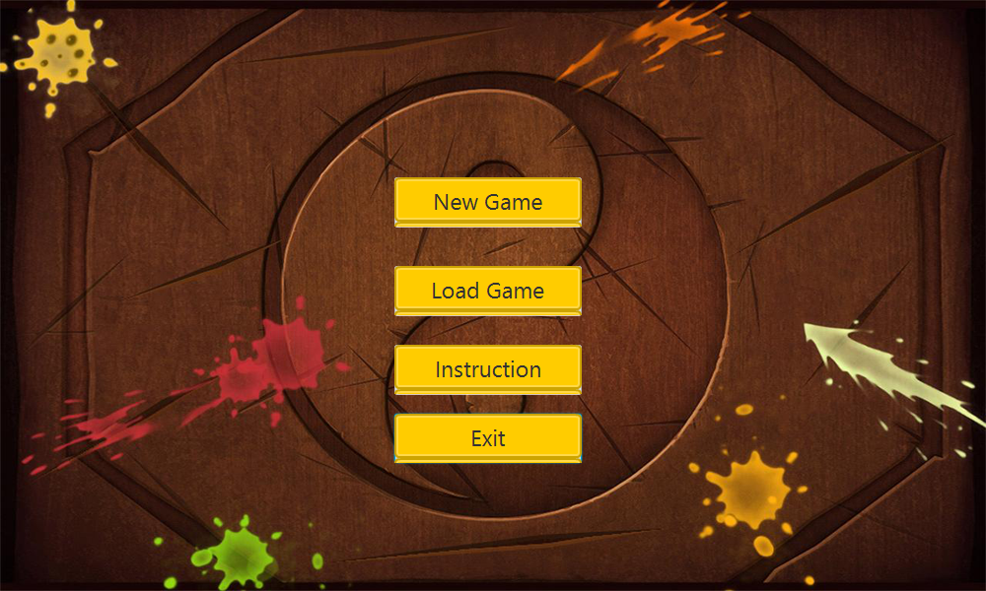

**It has 2 modes:**

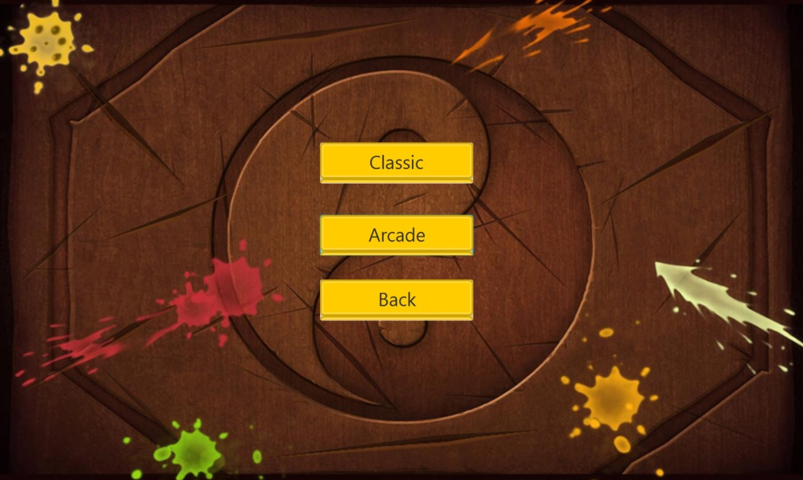

**Each mode has 3 difficulties:**

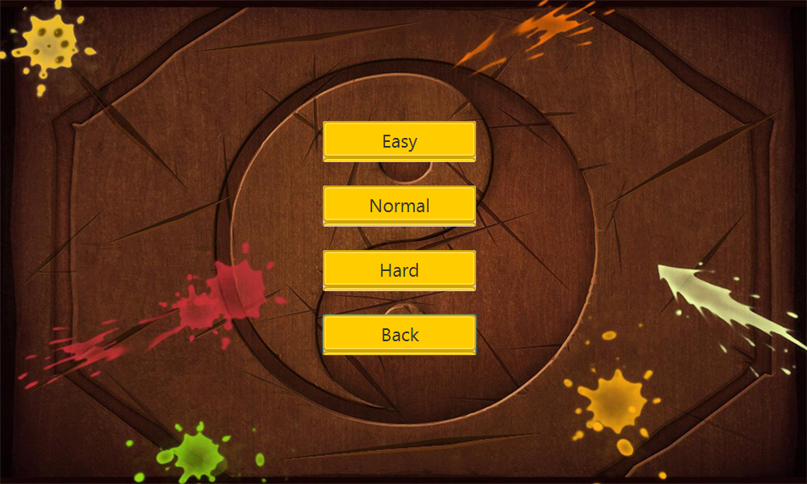

**Gameplay:**

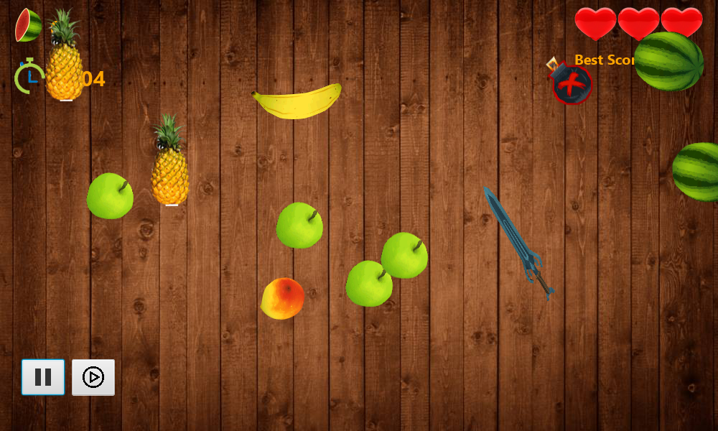

In classic mode: The hearts represents your 3 lives in the game, you lose 1 life when you miss a fruit without slicing it.

Your score appears on the top left corner.

Highscore appears on the top right corner.

You can pause the game and resume it.

You can load your score again from the main menu, game has auto save feature.

If you slice a bomb you’ll lose 1 life, and there’s a fetal bomb which ends the game.

The pineapple doubles your score.

The special Fruit (which appears after slicing on the screen) decreases speed of falling fruits.

Arcade mode: you play for a minute without bombs and try to beat the highscore.

**Game over:**

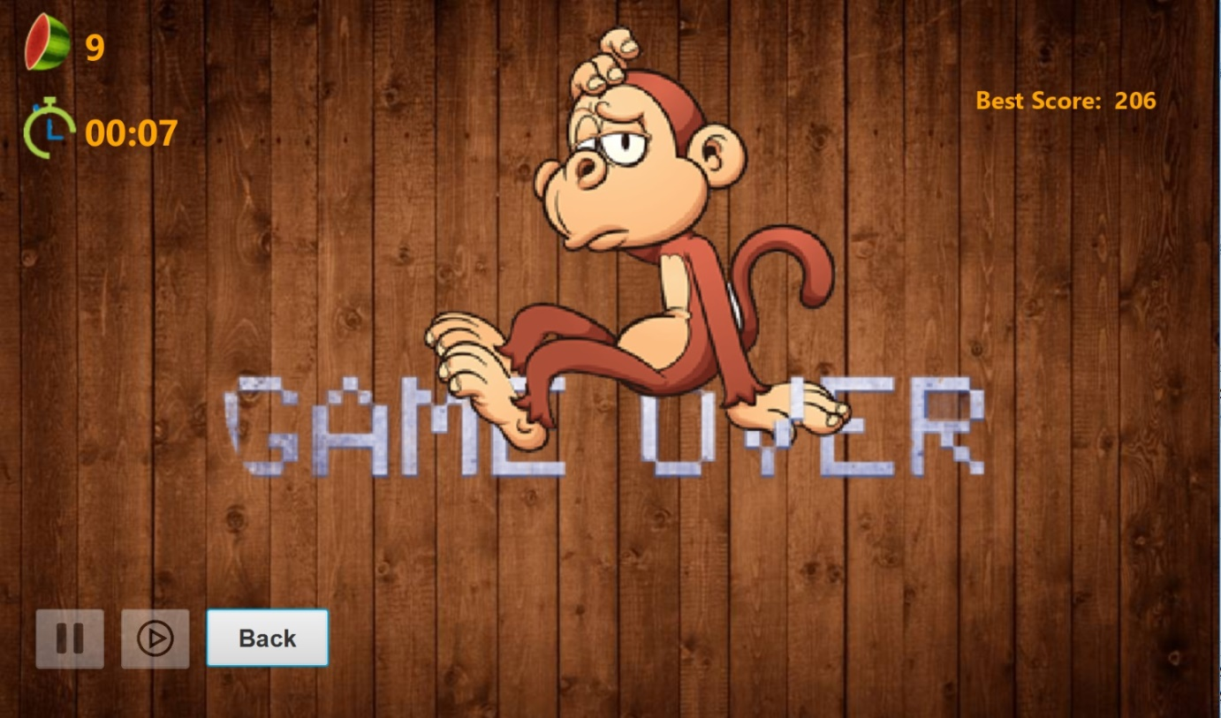

In Classic Mode: Game is over when the player lose his three lives

In Arcade Mode: Game is over when time ends.

After the Game is over the player can go back again to the Main Menu through back button.

**Design Patterns:**

**MVC:**

Model represents all the objects with its details

View represents the GUI

Control connects between the Model and the View.

**Decorator:** Used to create special fruits and bombs.

**Command:** Used in the Save and Load feature.

**Strategy:** Used to create Levels.

**Singleton:** Used to create one Controller and one Sword.

**Factory:** Used to create variety of Fruits.